* **For any of A chosen, identify the various objects, their attributes and relationships;**

We shall focus on the number of dead, infected, healed and active cases per state in Nigeria.

* **Provide the geographic extent of the chosen area using standard cartographic principles of map productions;**

The geographic extent of Nigeria can be described using standard cartographic principles, including latitude and longitude coordinates and the boundaries of the country. Here is the geographic extent of Nigeria:

Latitude: Nigeria is located approximately between 4° and 14° North latitude.

Longitude: Nigeria is situated approximately between 2° and 15° East longitude.

Boundaries:

Nigeria shares borders with the following countries:

To the North: Niger

To the Northeast: Chad

To the East: Cameroon

To the West: Benin

The coastal areas of Nigeria lie along the Gulf of Guinea in the Atlantic Ocean. Nigeria's coastline stretches for approximately 853 kilometers (530 miles) from the southwestern region to the southeastern region.

Please note that the geographic extent provided here is a general description of Nigeria's boundaries and coordinates. For precise and accurate mapping purposes, it is recommended to refer to authoritative sources, such as official maps, geospatial data, or geographic information systems (GIS) that provide detailed and up-to-date information about Nigeria's geography.

* **Get the satellite imageries of the given study areas and carry out necessary analysis**

Satellite Image of Nigeria

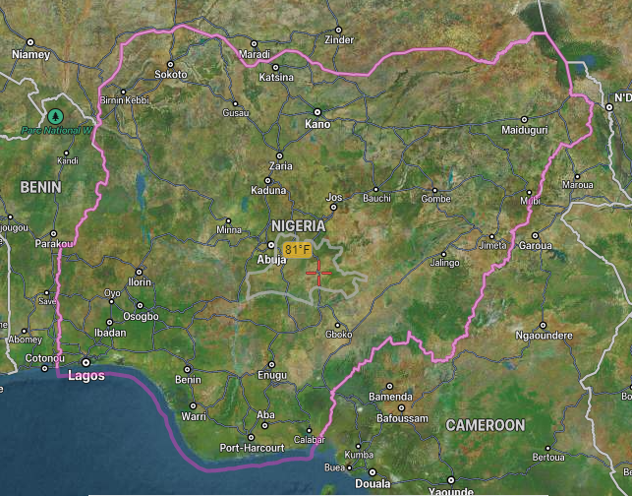

To analyze the data, we used Python language and Jupyter Notebook

The dataset from the Nigerian Covid-19 cases was gotten from NCDC, while the global dataset was gotten from the WHO website.

The below Python libraries were used.

import pandas as pd

import numpy as np

import matplotlib.pyplot as plt

import seaborn as sns

import plotly.express as px

from plotly.subplots import make_subplots

from datetime import datetime

The NCDC datasets used provided figures for those Infected, Dead and Healed. We calculated the figures for those still Active by

Active = Infected – (Dead + Healed)

| ID | DATE | ISO_3 | COUNTRY | ID_COUNTRY | STATE | ID_STATE | INFECTED | DEAD | HEALED | ACTIVE | INFECTED_NON_SPECIFIC_GENDER | SOURCE |
| --- | --- | --- | --- | --- | --- | --- | --- | --- | --- | --- | --- | --- |
| 1 | 2/27/2020 - 2/2/2022 | NGA | Nigéria | 15 | Abia | 170 | 2152 | 34 | 2112 | 6 | 1254 | Nigeria Centre for Disease Control |  |
| 2 | 2/27/2020 - 2/2/2022 | NGA | Nigéria | 15 | Adamawa | 171 | 1203 | 32 | 1103 | 68 | 955 | Nigeria Centre for Disease Control |  |
| 3 | 2/27/2020 - 2/2/2022 | NGA | Nigéria | 15 | Akwa Ibom | 172 | 4625 | 44 | 4494 | 87 | 4330 | Nigeria Centre for Disease Control |  |
| 4 | 2/27/2020 - 2/2/2022 | NGA | Nigéria | 15 | Anambra | 173 | 2743 | 19 | 2678 | 46 | 2468 | Nigeria Centre for Disease Control |  |
| 5 | 2/27/2020 - 2/2/2022 | NGA | Nigéria | 15 | Bauchi | 174 | 1936 | 24 | 1878 | 34 | 1226 | Nigeria Centre for Disease Control |  |
| 6 | 2/27/2020 - 2/2/2022 | NGA | Nigéria | 15 | Bayelsa | 175 | 1305 | 28 | 1277 | 0 | 902 | Nigeria Centre for Disease Control |  |
| 7 | 2/27/2020 - 2/2/2022 | NGA | Nigéria | 15 | Benue | 176 | 2129 | 25 | 1764 | 340 | 1645 | Nigeria Centre for Disease Control |  |
| 8 | 2/27/2020 - 2/2/2022 | NGA | Nigéria | 15 | Borno | 177 | 1629 | 44 | 1580 | 5 | 884 | Nigeria Centre for Disease Control |  |
| 9 | 2/27/2020 - 2/2/2022 | NGA | Nigéria | 15 | Cross River | 178 | 778 | 25 | 746 | 7 | 691 | Nigeria Centre for Disease Control |  |
| 10 | 2/27/2020 - 2/2/2022 | NGA | Nigéria | 15 | Delta | 179 | 5328 | 111 | 5170 | 47 | 3516 | Nigeria Centre for Disease Control |  |
| 11 | 2/27/2020 - 2/2/2022 | NGA | Nigéria | 15 | Ebonyi | 180 | 2064 | 32 | 2004 | 28 | 1015 | Nigeria Centre for Disease Control |  |
| 12 | 2/27/2020 - 2/2/2022 | NGA | Nigéria | 15 | Edo | 181 | 7672 | 320 | 7335 | 17 | 5029 | Nigeria Centre for Disease Control |  |
| 13 | 2/27/2020 - 2/2/2022 | NGA | Nigéria | 15 | Ekiti | 182 | 1978 | 28 | 1919 | 31 | 1650 | Nigeria Centre for Disease Control |  |
| 14 | 2/27/2020 - 2/2/2022 | NGA | Nigéria | 15 | Enugu | 183 | 2952 | 29 | 2910 | 13 | 1639 | Nigeria Centre for Disease Control |  |
| 15 | 2/27/2020 - 2/2/2022 | NGA | Nigéria | 15 | Federal Capital Territory | 184 | 28187 | 247 | 27405 | 535 | 22277 | Nigeria Centre for Disease Control |  |
| 16 | 2/27/2020 - 2/2/2022 | NGA | Nigéria | 15 | Gombe | 185 | 3270 | 64 | 3103 | 103 | 2387 | Nigeria Centre for Disease Control |  |
| 17 | 2/27/2020 - 2/2/2022 | NGA | Nigéria | 15 | Imo | 186 | 2442 | 58 | 2268 | 116 | 1853 | Nigeria Centre for Disease Control |  |
| 18 | 2/27/2020 - 2/2/2022 | NGA | Nigéria | 15 | Jigawa | 187 | 664 | 18 | 642 | 4 | 339 | Nigeria Centre for Disease Control |  |
| 19 | 2/27/2020 - 2/2/2022 | NGA | Nigéria | 15 | Kaduna | 188 | 11185 | 89 | 11073 | 23 | 8635 | Nigeria Centre for Disease Control |  |
| 20 | 2/27/2020 - 2/2/2022 | NGA | Nigéria | 15 | Kano | 189 | 4919 | 126 | 4726 | 67 | 3178 | Nigeria Centre for Disease Control |  |
| 21 | 2/27/2020 - 2/2/2022 | NGA | Nigéria | 15 | Katsina | 190 | 2399 | 37 | 2339 | 23 | 1497 | Nigeria Centre for Disease Control |  |
| 22 | 2/27/2020 - 2/2/2022 | NGA | Nigéria | 15 | Kebbi | 191 | 480 | 16 | 454 | 10 | 387 | Nigeria Centre for Disease Control |  |
| 23 | 2/27/2020 - 2/2/2022 | NGA | Nigéria | 15 | Kogi | 192 | 5 | 2 | 3 | 0 | 0 | Nigeria Centre for Disease Control |  |
| 24 | 2/27/2020 - 2/2/2022 | NGA | Nigéria | 15 | Kwara | 193 | 4541 | 64 | 4175 | 302 | 3491 | Nigeria Centre for Disease Control |  |
| 25 | 2/27/2020 - 2/2/2022 | NGA | Nigéria | 15 | Lagos | 194 | 98366 | 769 | 80066 | 17531 | 77821 | Nigeria Centre for Disease Control |  |
| 26 | 2/27/2020 - 2/2/2022 | NGA | Nigéria | 15 | Nasarawa | 195 | 2703 | 39 | 2345 | 319 | 2227 | Nigeria Centre for Disease Control |  |
| 27 | 2/27/2020 - 2/2/2022 | NGA | Nigéria | 15 | Niger | 196 | 1142 | 20 | 998 | 124 | 869 | Nigeria Centre for Disease Control |  |
| 28 | 2/27/2020 - 2/2/2022 | NGA | Nigéria | 15 | Ogun | 197 | 5798 | 82 | 5705 | 11 | 3820 | Nigeria Centre for Disease Control |  |
| 29 | 2/27/2020 - 2/2/2022 | NGA | Nigéria | 15 | Ondo | 199 | 5143 | 107 | 4673 | 363 | 3489 | Nigeria Centre for Disease Control |  |
| 30 | 2/27/2020 - 2/2/2022 | NGA | Nigéria | 15 | Osun | 198 | 3276 | 92 | 3127 | 57 | 2368 | Nigeria Centre for Disease Control |  |
| 31 | 2/27/2020 - 2/2/2022 | NGA | Nigéria | 15 | Oyo | 200 | 10196 | 201 | 9634 | 361 | 6787 | Nigeria Centre for Disease Control |  |
| 32 | 2/27/2020 - 2/2/2022 | NGA | Nigéria | 15 | Plateau | 201 | 0 | 75 | 10149 | -10224 | 6647 | Nigeria Centre for Disease Control |  |
| 33 | 2/27/2020 - 2/2/2022 | NGA | Nigéria | 15 | Rivers | 202 | 16422 | 154 | 16148 | 120 | 13726 | Nigeria Centre for Disease Control |  |
| 34 | 2/27/2020 - 2/2/2022 | NGA | Nigéria | 15 | Sokoto | 203 | 811 | 28 | 783 | 0 | 649 | Nigeria Centre for Disease Control |  |
| 35 | 2/27/2020 - 2/2/2022 | NGA | Nigéria | 15 | Taraba | 204 | 1469 | 34 | 1377 | 58 | 1352 | Nigeria Centre for Disease Control |  |
| 36 | 2/27/2020 - 2/2/2022 | NGA | Nigéria | 15 | Yobe | 205 | 509 | 9 | 490 | 10 | 430 | Nigeria Centre for Disease Control |  |
| 37 | 2/27/2020 - 2/2/2022 | NGA | Nigéria | 15 | Zamfara | 206 | 375 | 9 | 366 | 0 | 296 | Nigeria Centre for Disease Contro |  |

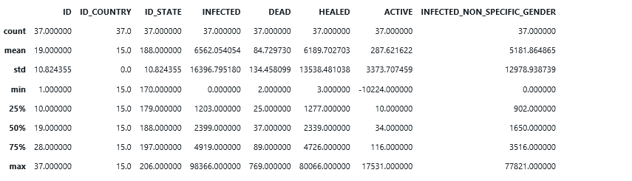

Regional Analysis

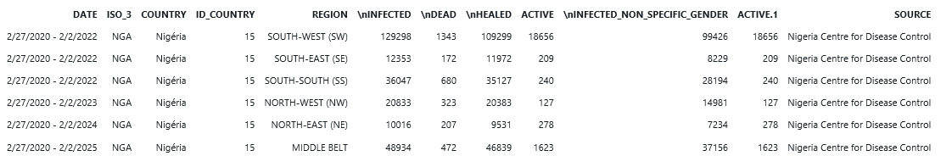

From here, we can calculate the recovery and mortality rates,

Recovery Rate = Total Healed for all states and Abuja/ Total Infected for all states and Abuja x 100

Mortality Rate = Total Dead for all states and Abuja/ Total Infected for all states and Abuja x 100

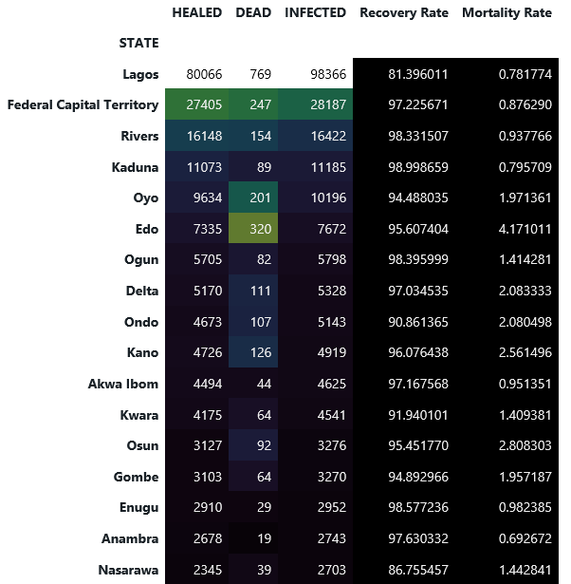 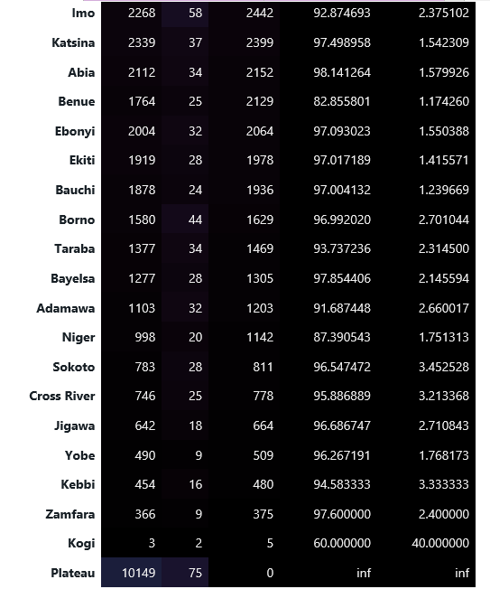

First 10 states with Most Active Covid-19 cases, arranged alphabetically.

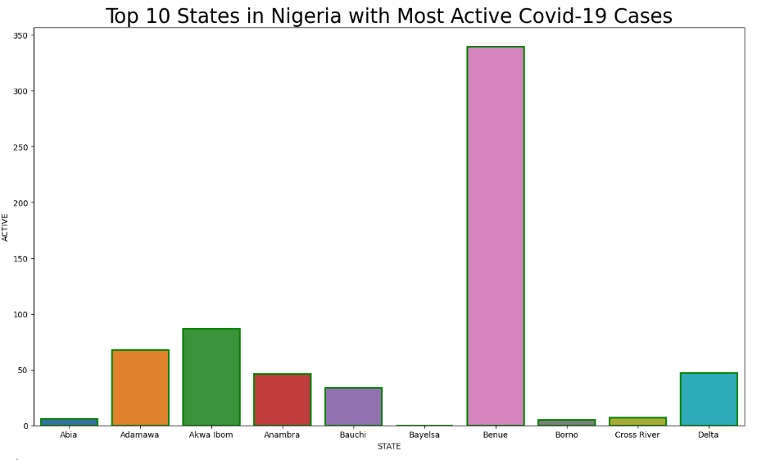

Top 10 states with Most Recorded COVID-19 Deaths

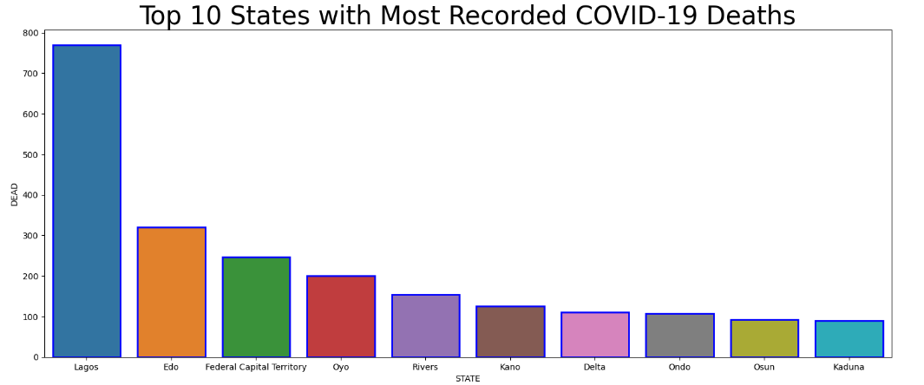

Regional Mortality and Recovery Rates

regionwise["Mortality Rate"] = regionwise["\nDEAD"]*100/regionwise["\nINFECTED"]

regionwise = regionwise.sort_values(by = "\nINFECTED", ascending = False)

regionwise.style.background_gradient(cmap = "cubehelix")

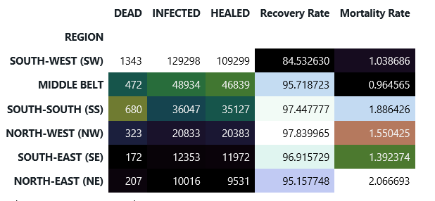

Active COVID-19 Cases By Regions in Nigeria

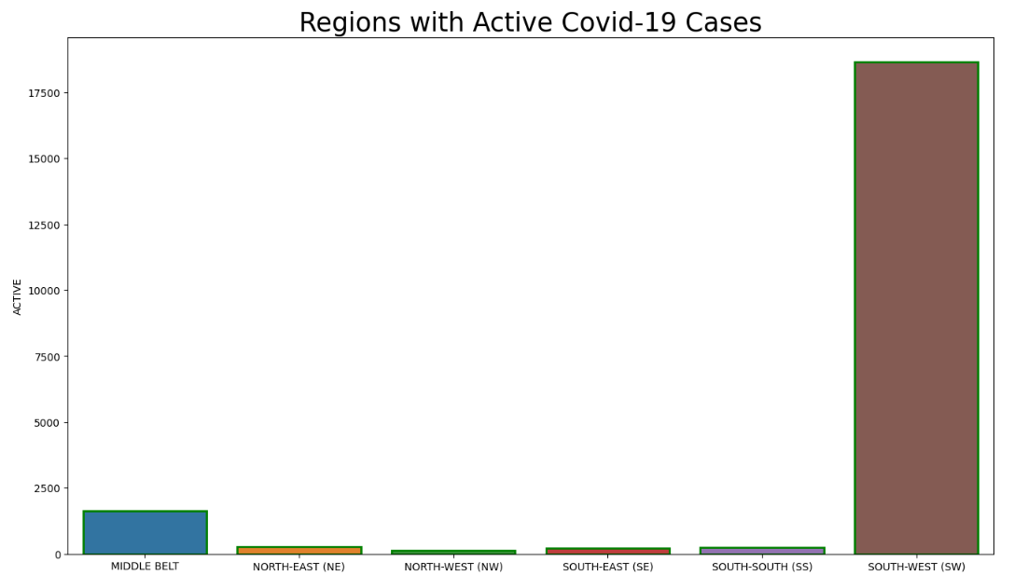

COVID-19 Global Data Visualizations

Dataset Source: WHO

Visualizations were derived from analyzing the dataset from WHO using Tableau

